Serena Sivaraj

32494343

Monday 10-12pm

URL: <https://ssiv0027.github.io/3179/>

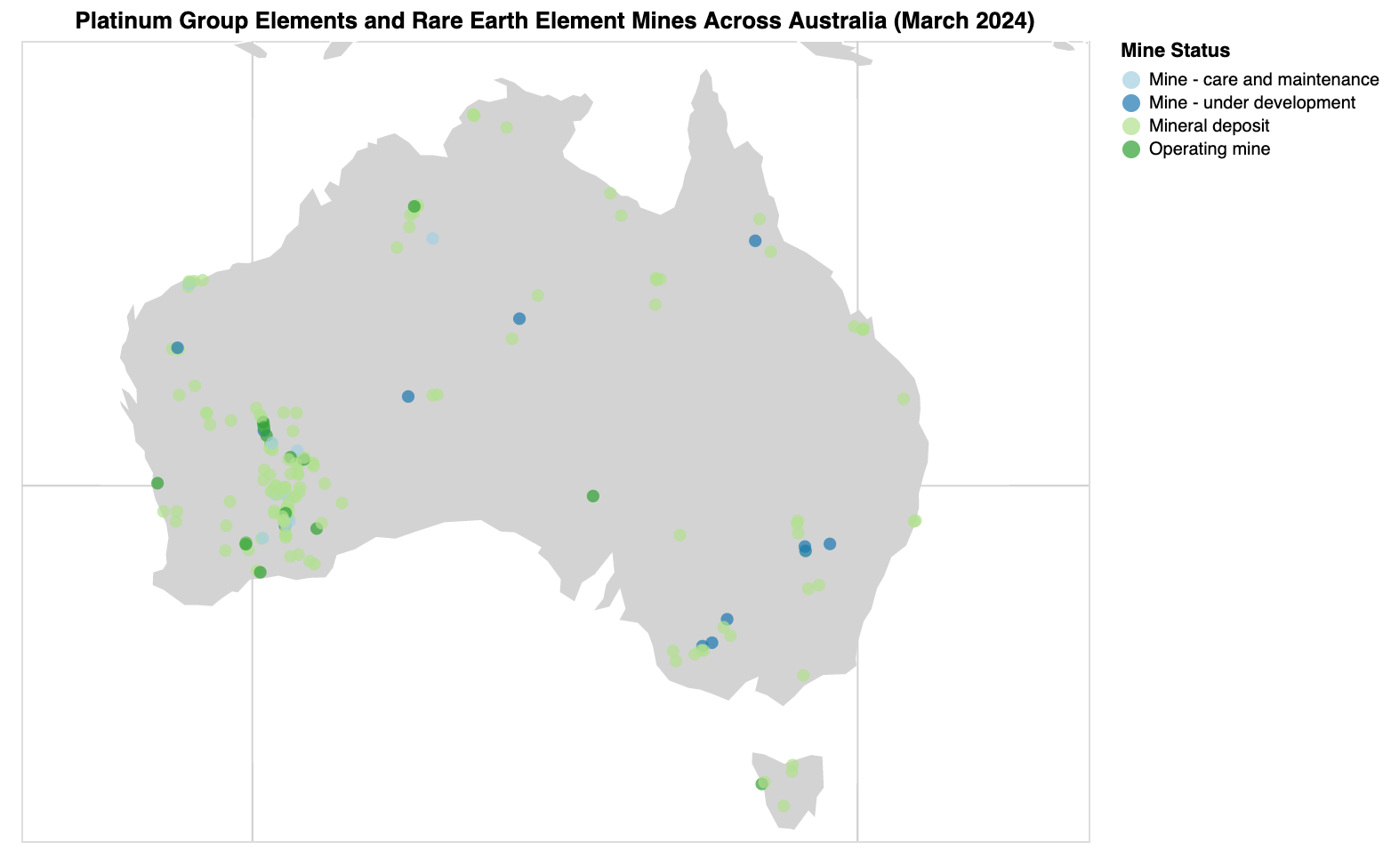

**Domain:** Location and status of Australian operating mines that mine Platinum Group Elements, Rare Earth Elements

**Attribute Types:** Categorical - Status, State ; Nominal - Longitude, Latitude

**Source:** https://ecat.ga.gov.au/geonetwork/srv/eng/catalog.search#/metadata/149108

**Author:** Geoscience Australia

**Data Transformation:** Filtered by Platinum Group Elements and Rare Earth Elements to focus on particular elements that could be of interest to investors of those elements

**Justification: I** used a dot map as it will help identify the density of mines across australia. Because there are different mine statuses, a proportion map wouldn't be appropriate as it does not clearly identify each mine.